Meme Creation Assignment
Created by Ellen Whitehead, Ball State University

The goal of this assignment is for students to connect new material that they are learning with an existing cultural touchstone. Students will demonstrate that they can apply the course concepts to the world around them by creating a meme that captures the meaning and the emotion of the material or concept.

Instructions

When learning about a new theory that makes you rethink a previous perspective, can you make a connection to your life, your friends, current events and/or popular culture? Whenever you make these kinds of connections, turn it into a meme! Memes must connect explicitly to course content (e.g. concepts, theories, or trends that we cover in class). Write a 4-5 sentence description of your meme and the course concept it illustrates.

Submissions must also be your original work. No downloading ones that already exist online!

How to create the meme: Find a meme generator; any one is fine, but here is one option: https://imgur.com/memegen.

Submit your image file (e.g. JPEG, PNG) to the course learning management system.

Please let me know if you have any questions about the assignment.

Subculture meme:
Created by Sophia Burl
Description: This meme highlights the difference between a subculture, which represents a subset of society with distinctive values or forms of behavior, and a counterculture, which develops as a form of rejection or an alternative to the dominant culture in a society.
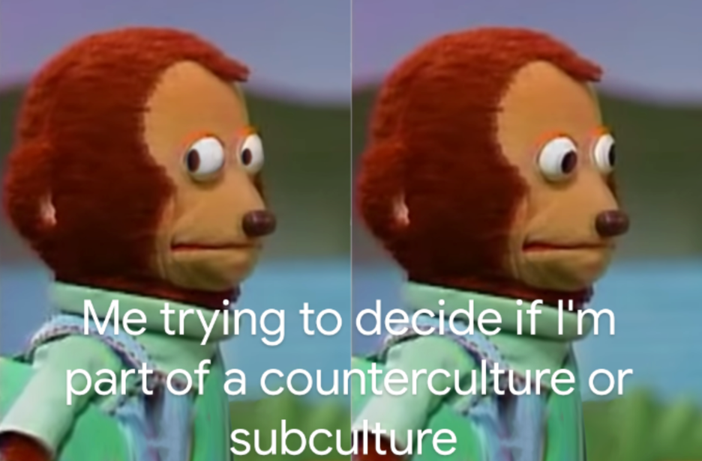

Ascribed status meme:
Created by Gayge Botkin
Description: This meme demonstrates the inescapable nature of ascribed statuses, which is a status that is imposed on an individual by society without regard for a person’s own individual attributes or accomplishments (for example, a person’s perceived gender or race). This is in contrast to an achieved status, which is based on a person’s efforts, actions, or achievements (for example, college student or CEO).

